Observation:

1. If only existing SKU is changed and running the pipeline the SKU is not been changed in the workspace. For the SKU to be changed we have to run a new pipeline with different RG.

Test 1: BUILD No: **#20221014.7**

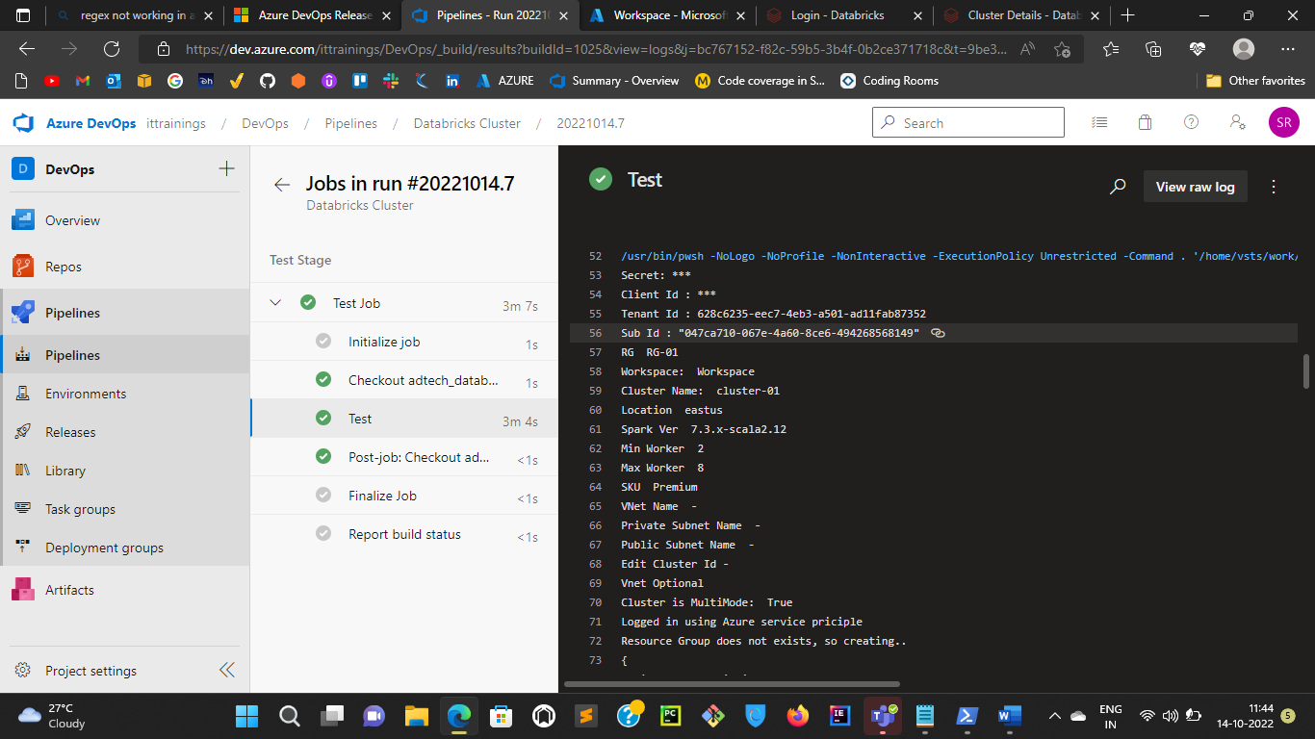

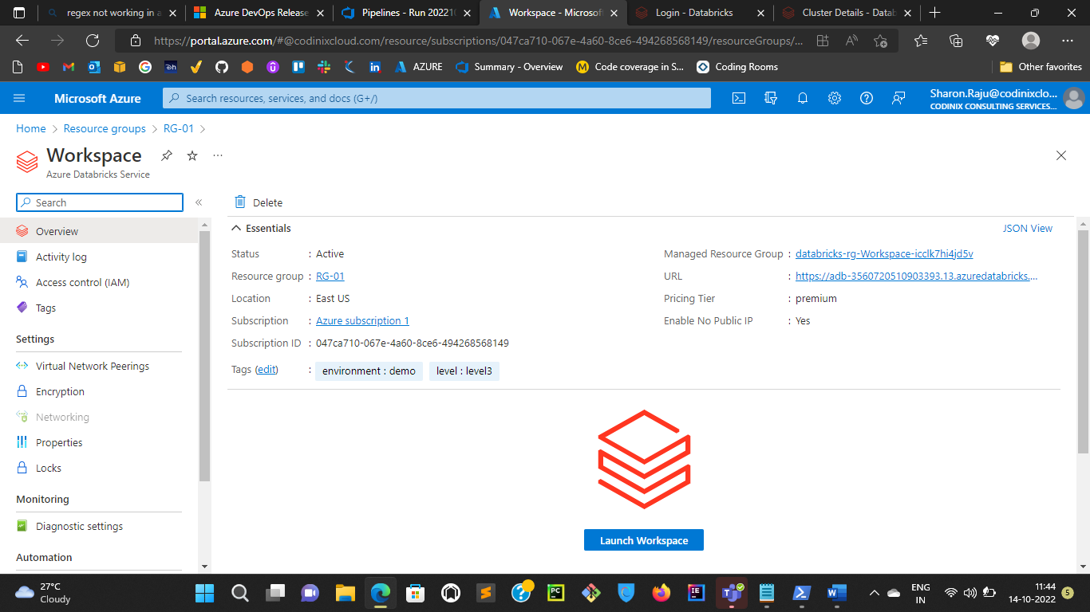

Test 2: **#20221014.8**

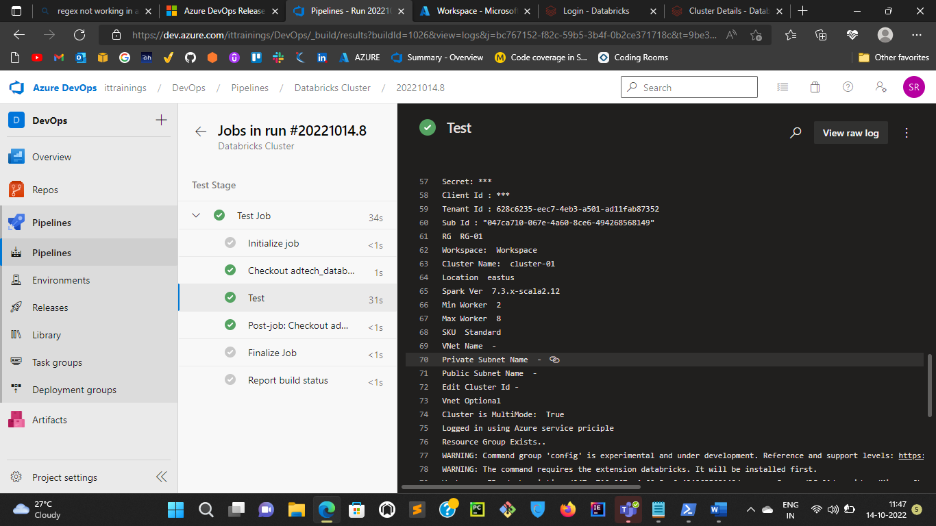

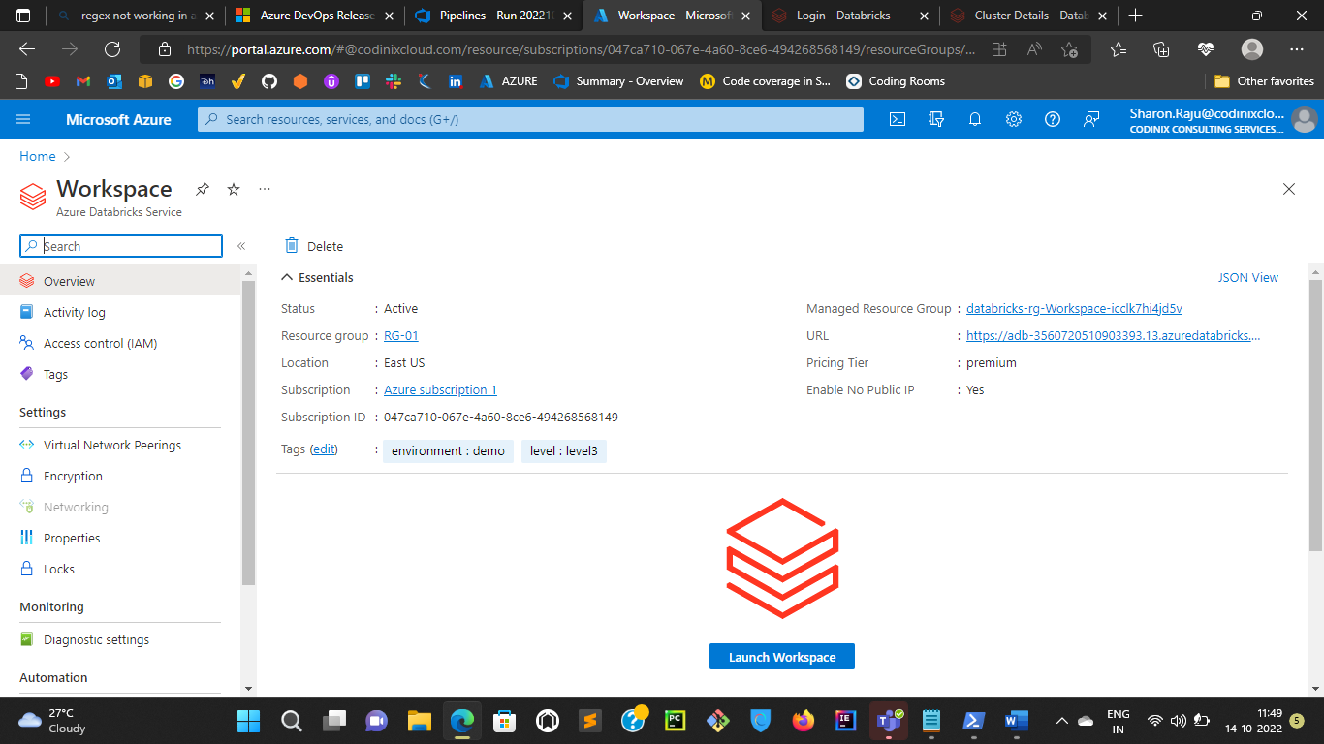

Observation: If you want to change any configurations in the existing cluster by giving existing cluster id, the pipeline is failing

Build No: **#20221014.11**

